L2 or L3 or tests name: ESG internal and external reporting
Legal entities in scope: DBAG/CBL/ECAG/CBF/CH/LuxCSD/CS/CI/CFCL/ExR/EFAG
Test(s) according to RCA:
1. Inquire on the internal and external reporting done in the context of ESG (employee satisfaction rate, woman in senior position, etc.)
2. Inquire on the stakeholders of the process and ensure this is correctly reflected in the ICS process map
3. Ensure controls are in place prior to reporting
4. Inquire on the different KPIs Employee satisfaction rate, Percentage of women in leadership positions, Number of funded social initiatives, Portion of variable compensation tied to ESG goals and inquire how are these monitored.

Risk:
incorrect/ inaccurate information reported to internal and external stakeholders

Conclusion: OK

Audit procedures/source:
Internal audit (PP) has performed the following Audit procedures:
- Inquiry: Held interviews with responsible stakeholders
- Vera Jordan – HR Business Partner
- Inspection: Of policies and evidences

Procedures / Criteria / documents used

Work Done:
Control Design Effectiveness
- Inquire on the internal and external reporting done in the context of ESG (employee satisfaction rate, woman in senior position, etc.)

External reporting is mainly related to the Financial Statements as follows:

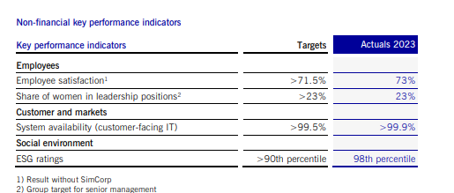

The ESG targets under section “Employees” are responsibility of HR and are reported to FA&C. The employee satisfaction rate is taken from the annual employee survey for which an external company is engaged to conduct the process of collection and analysis of data.

The share of woman in leadership position is taken at the end of the year and it is calculated as a percentage of the total amount of leadership positions. The data on this is usually public and it should be in line with the Germany`s Leadership Positions Act (FüPoG).

In addition the Health and Safety policy and the Anti-Harassment policy are published on the DBG website.

No other reports owned by HR in regards to ESG matters.

OK

- Inquire on the stakeholders of the process and ensure this is correctly reflected in the ICS process map

The above process is covered by two procedures in place

OK

- Ensure controls are in place prior to reporting

IA reviewed the above two procedure and noted the controls (4EP checks) are described.

OK

4. Inquire on the different KPIs Employee satisfaction rate, Percentage of women in leadership positions, Number of funded social initiatives, Portion of variable compensation tied to ESG goals and inquire how are these monitored.

For Employee satisfaction rate and Percentage of women in leadership positions refer to the above point 1
Number of funded social initiatives is part of the annual Corporate engagement report and this is under the responsibility of Marketing and Communications team.
Portion of variable compensation tied to ESG goals is reviewed as part of the L2 Merit Process for Board Members and Executives.

OK

Results:
The control operating effectiveness is assessed as effective

